**Evidence for Project Unit**

Name: Heather Rae

Cohort: 15

Date here: 2017

**P- 1 Github Contributors page**

**P- 2 Project Brief**

Write your project brief here for the group project, if you cannot remember ask one of the instructors or try to write one yourself based on the project you have created.

**P-3 Use of Trello**

**P-4 Acceptance Criteria**

**P-5 User sitemap**

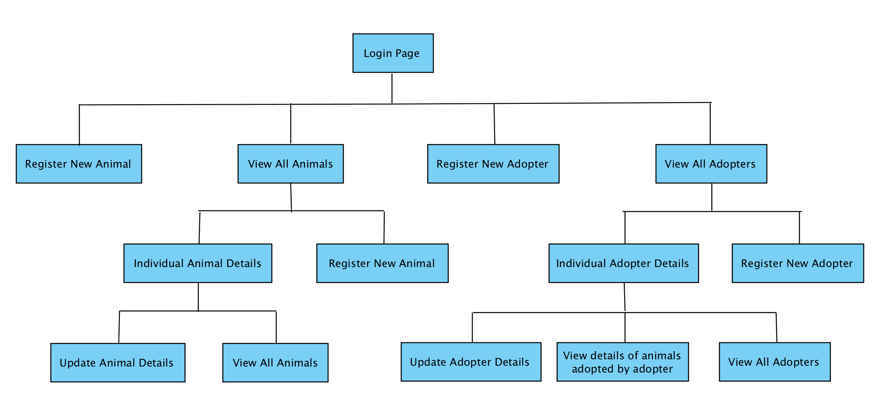

**P-6 Wireframes designs**

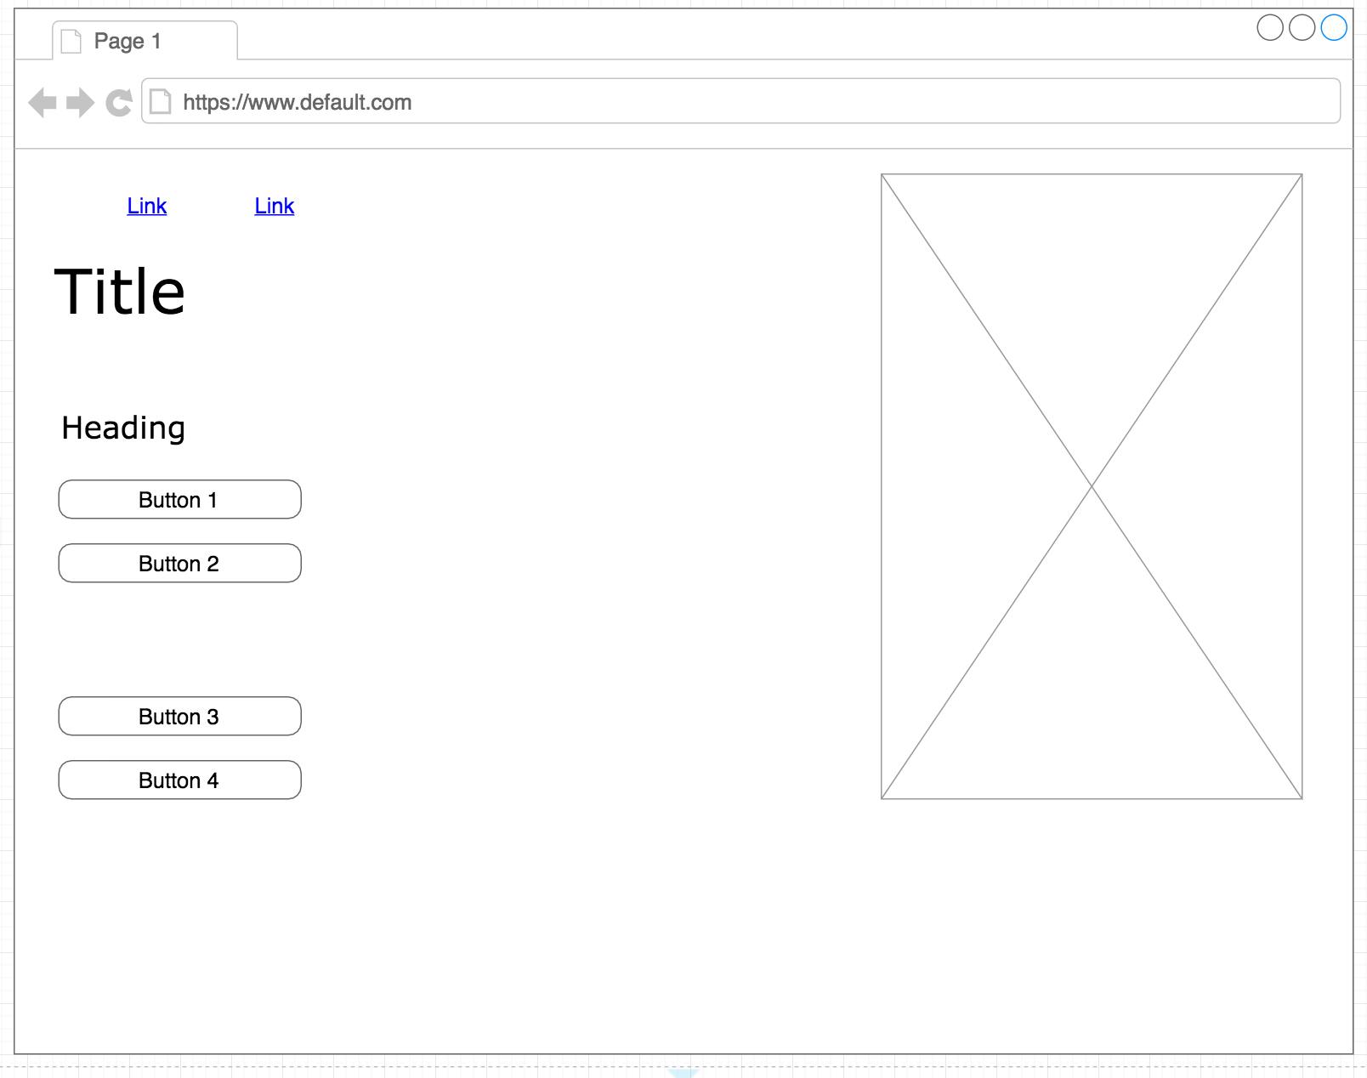

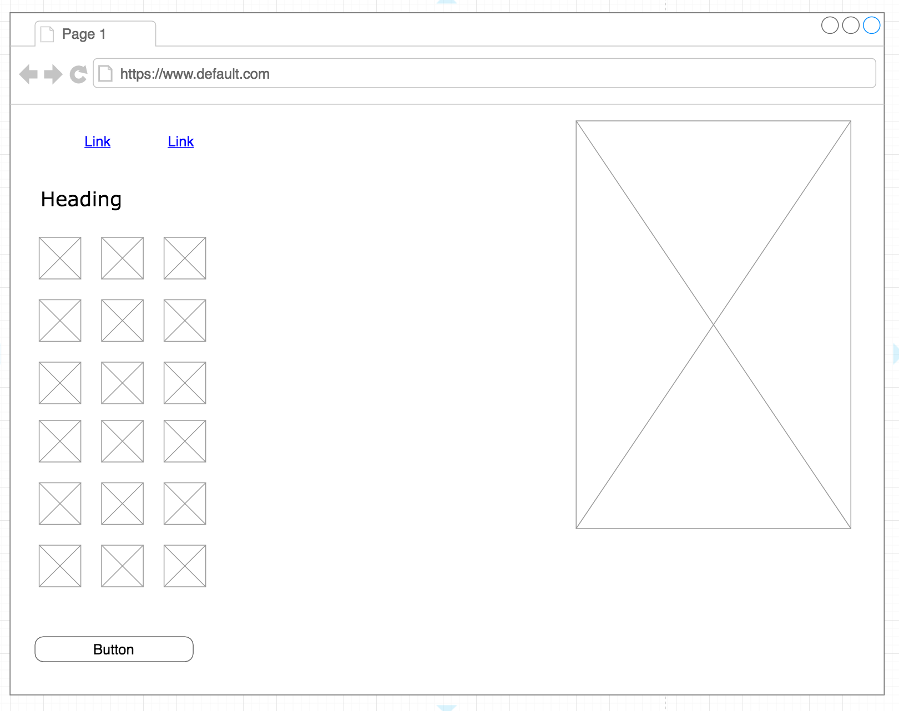

**P-7 System interactions diagrams**

**P-8 Two Object Diagrams**

**P- 9 D.T.- a Choice of two algorithms (find the algorithms on a program you might have written, show the code you have used. )**

**P - 10 Example of Pseudocode**

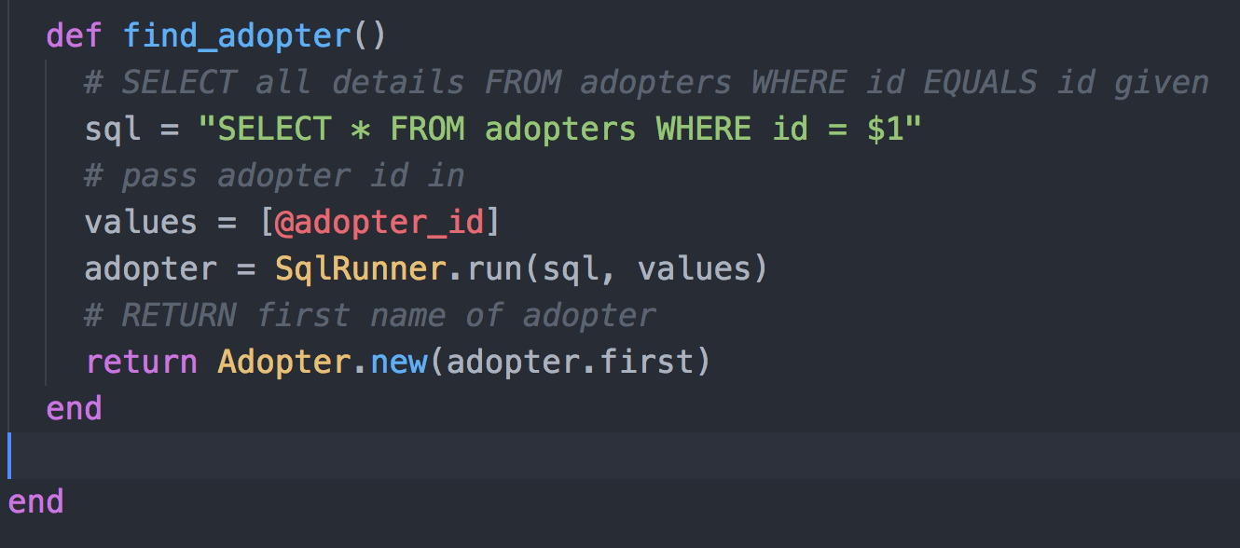

**P - 11 Take a screenshot of one of your projects where you have worked alone and attach the Github link.**

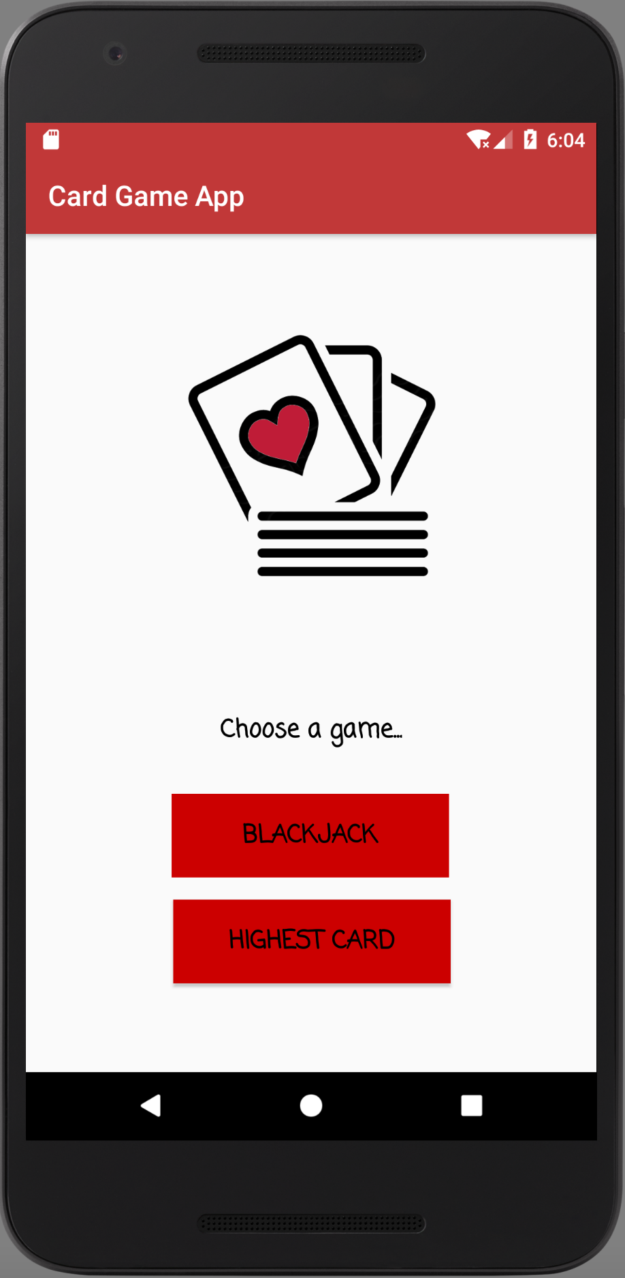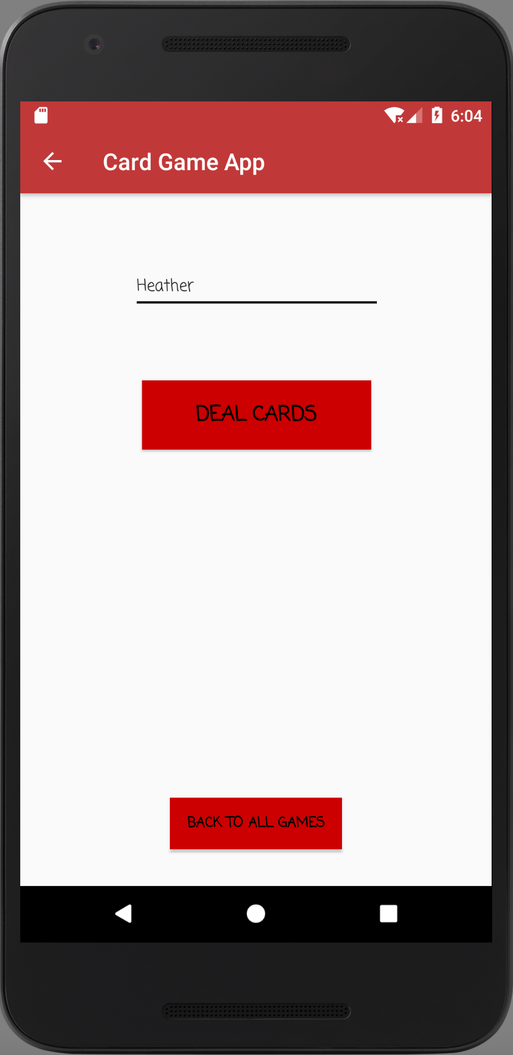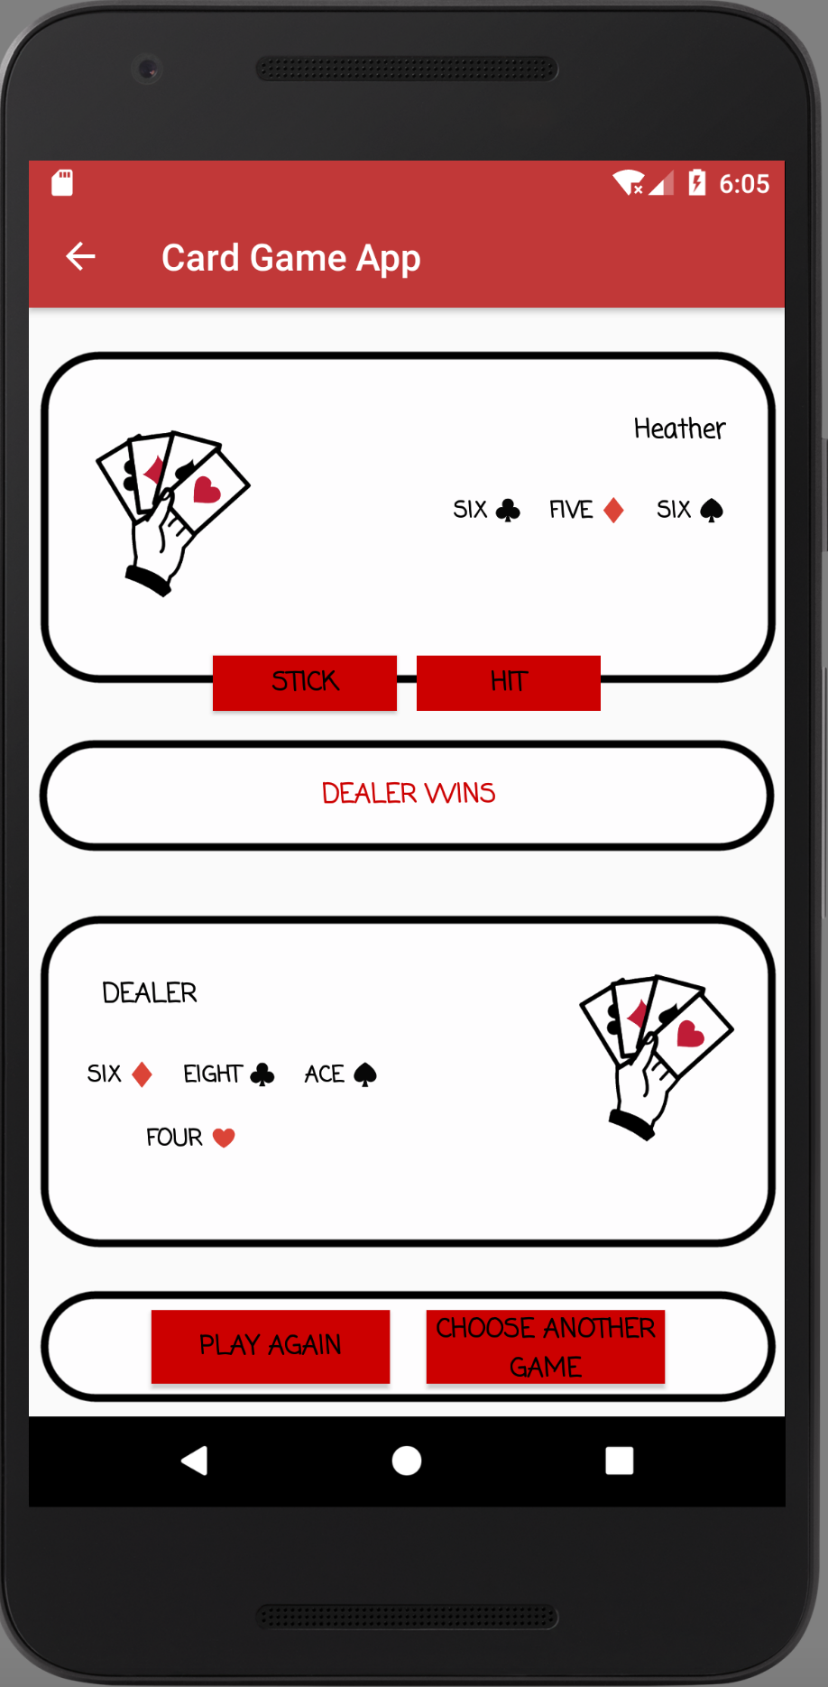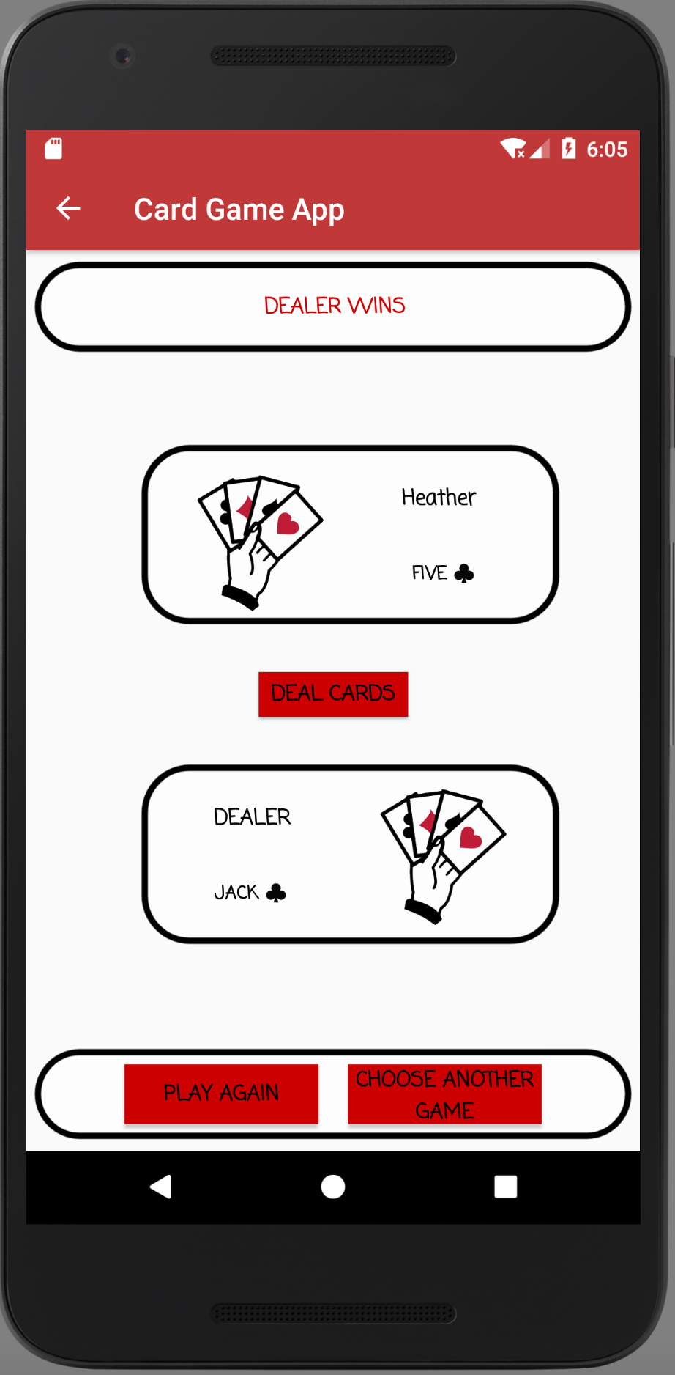

**https://github.com/heatherrae150/Java-BlackJack**

**P - 12 Screenshot of your planning and the different stages of development to show changes.**

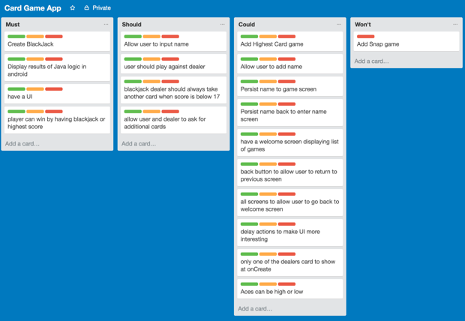

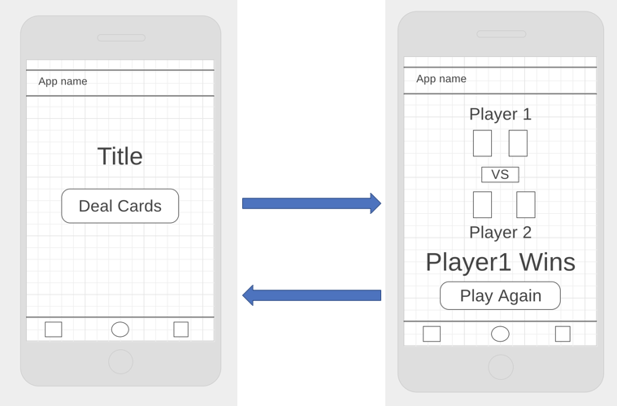

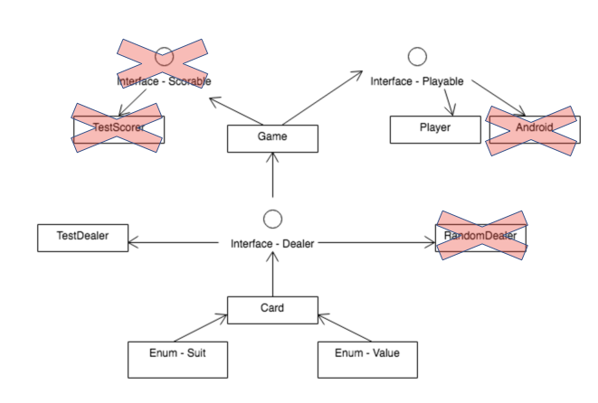

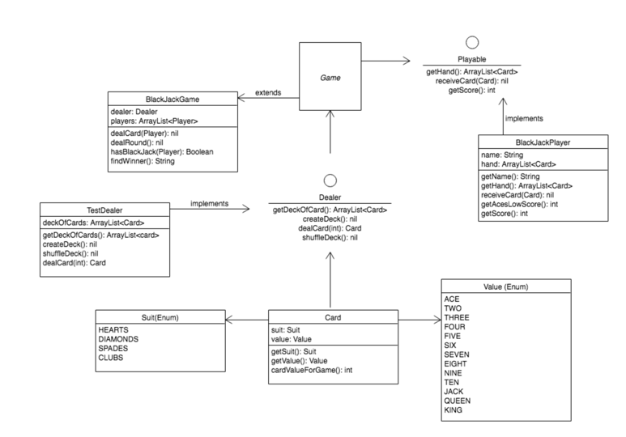

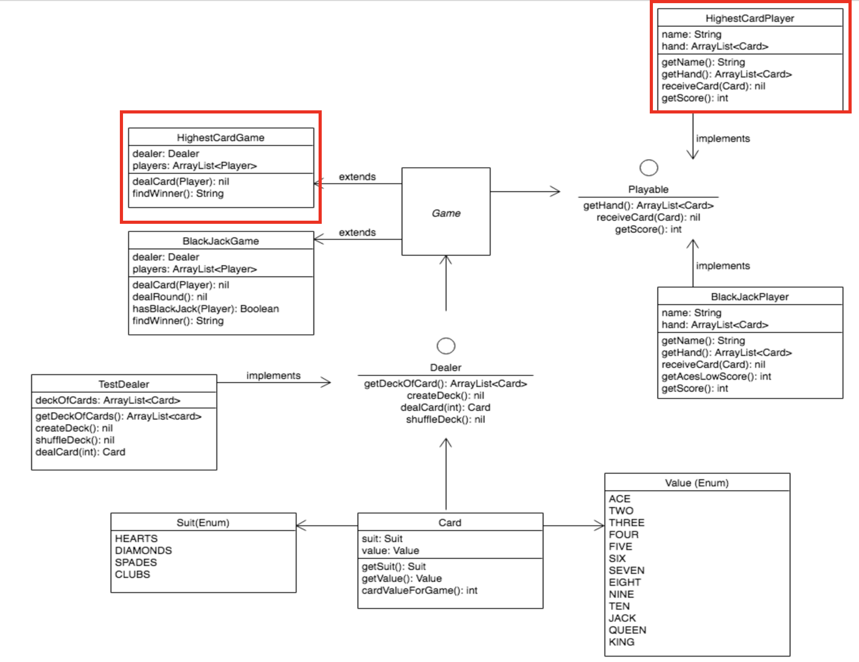

**P - 13 User input**

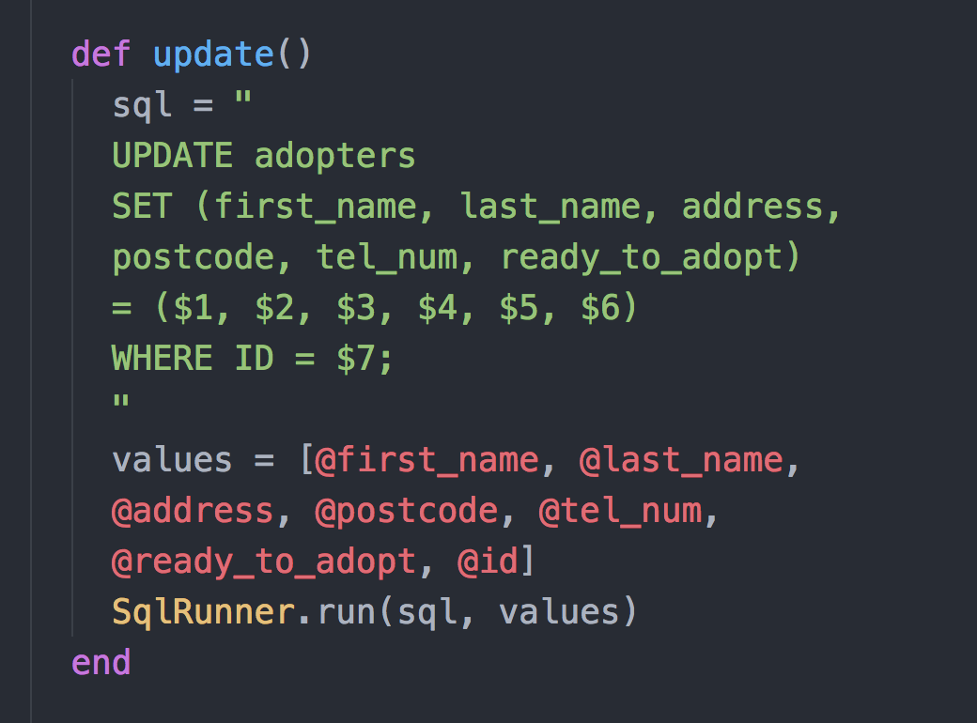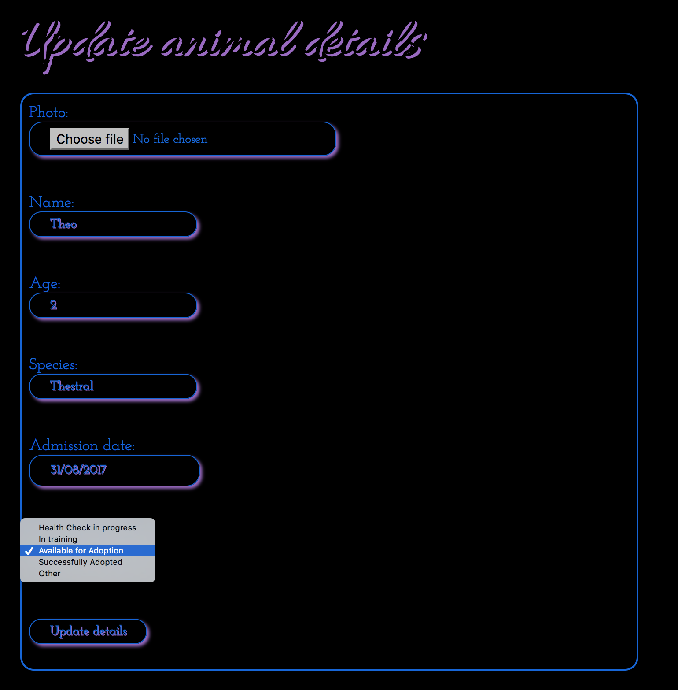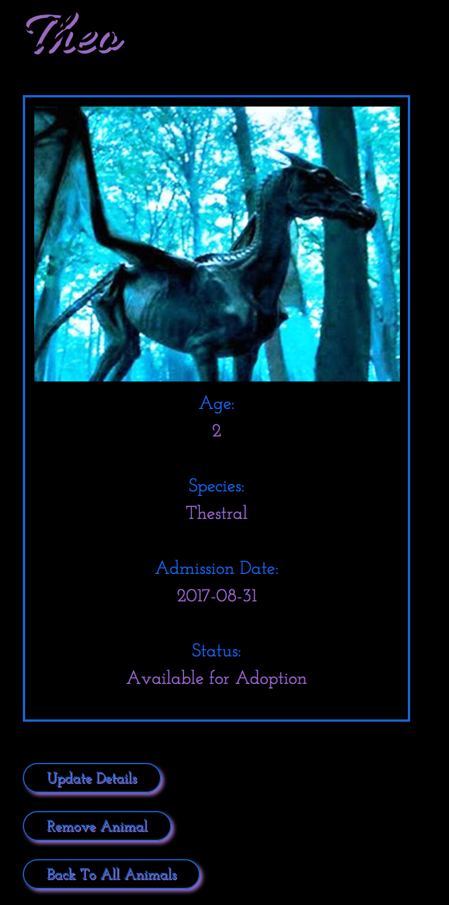

**P - 14 Interaction with data persistence**

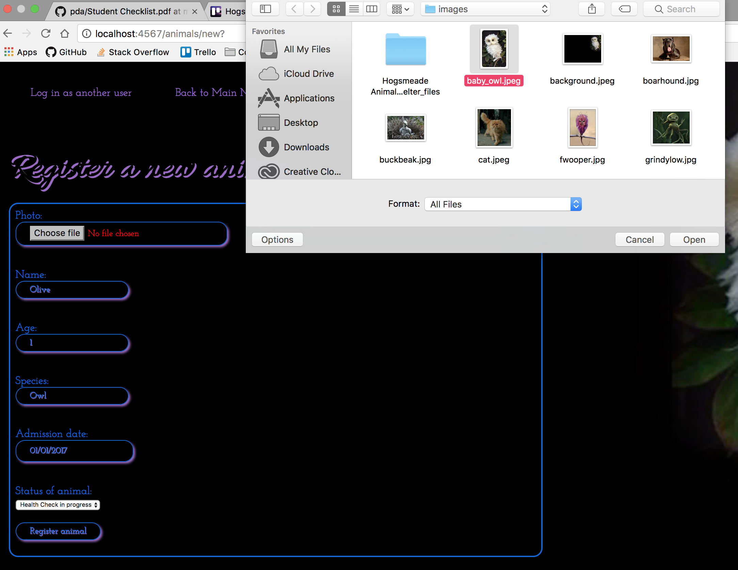

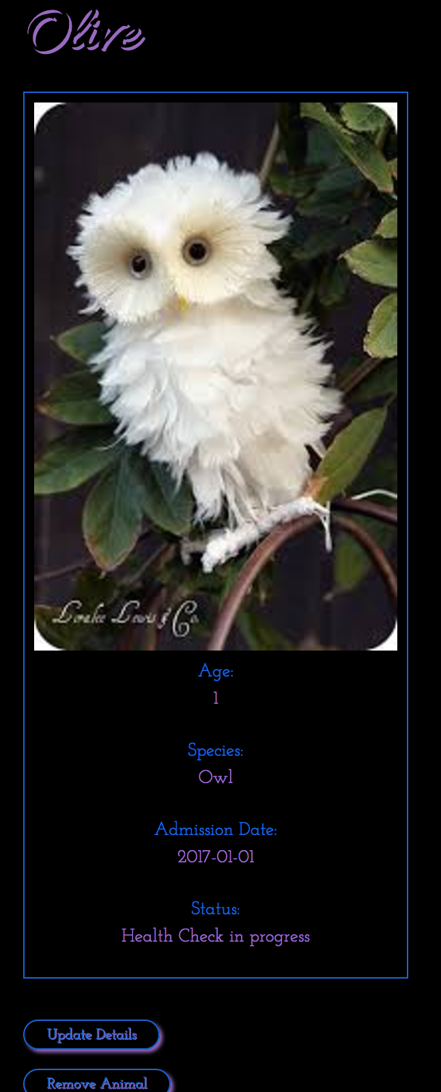

**P - 15 User output result**

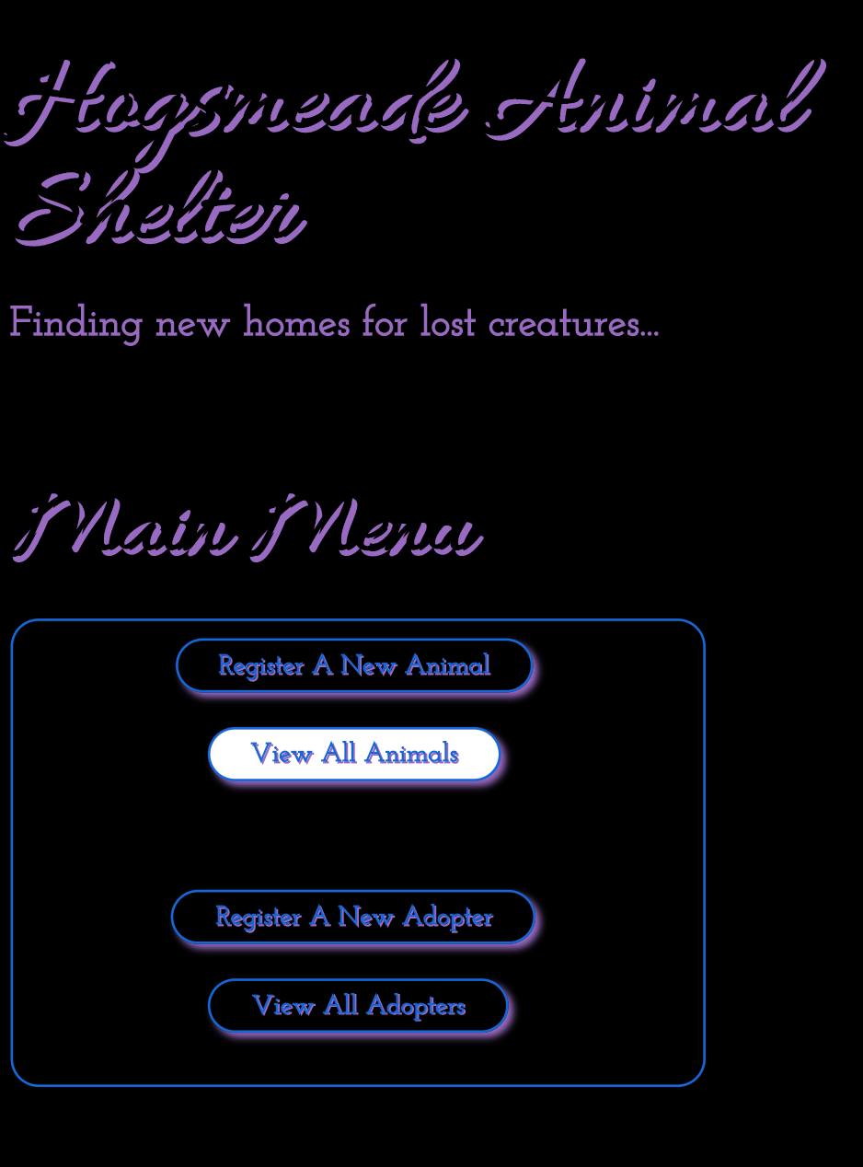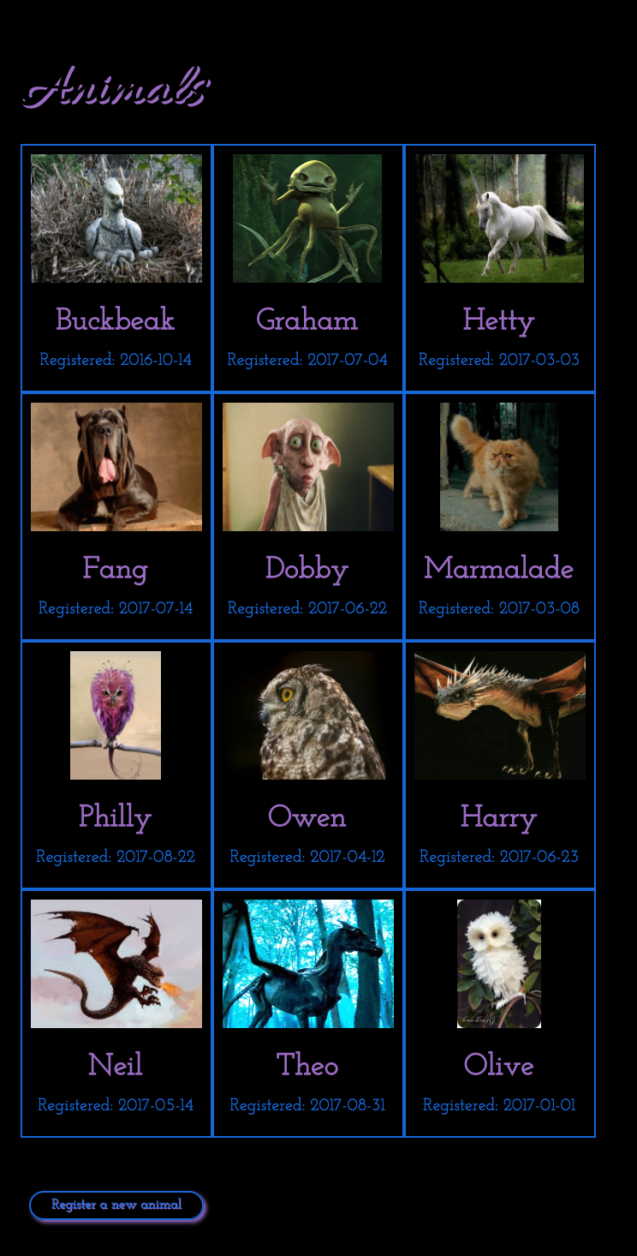

**P - 16 Show an API being used within your program.**

**P -17 Produce a bug tracking report**

**P - 18 Demonstrate testing in your program.**

**Test failing**

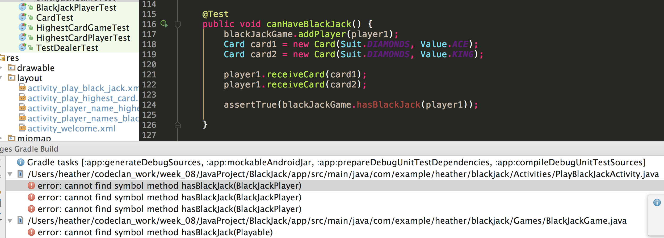

**Test passing**

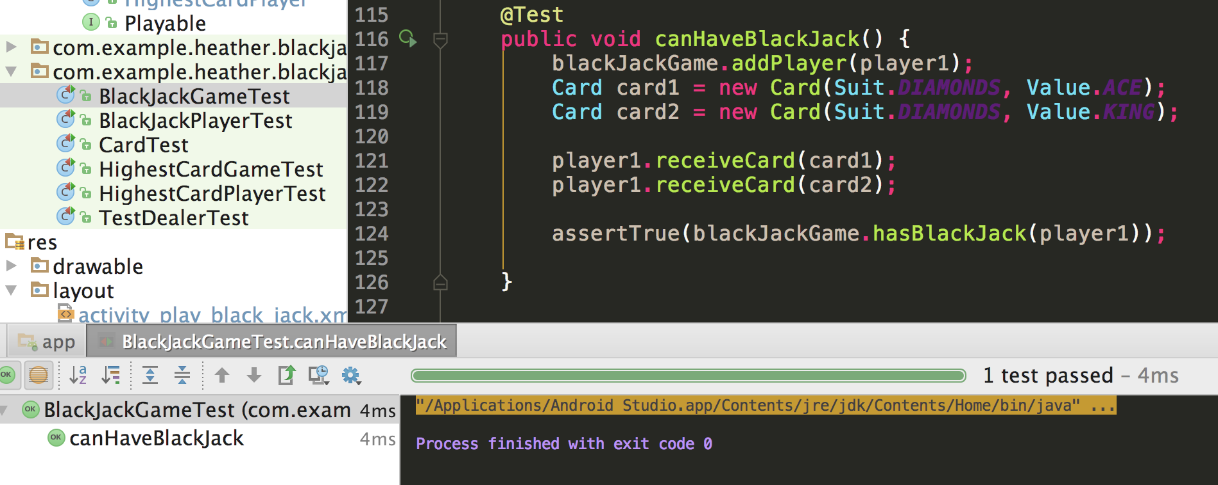

**Test failing**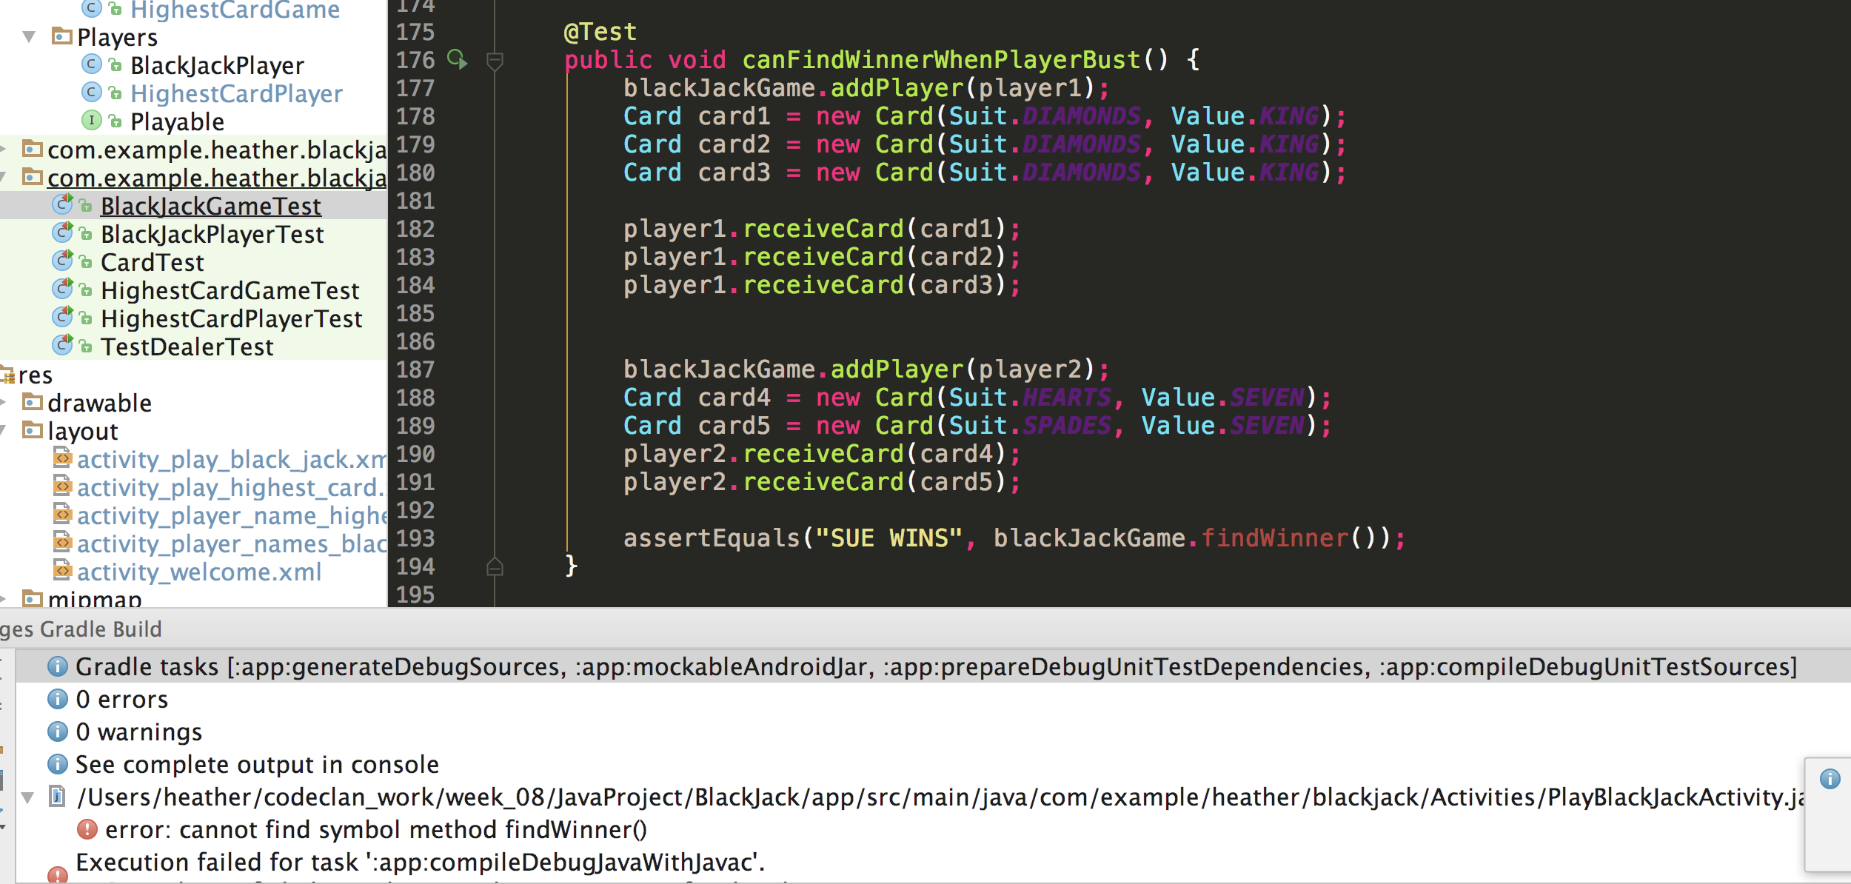

**Test passing**

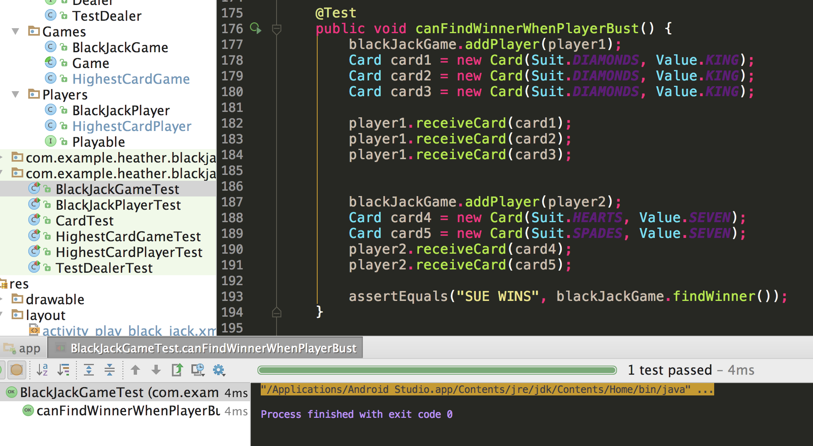

**Test failing**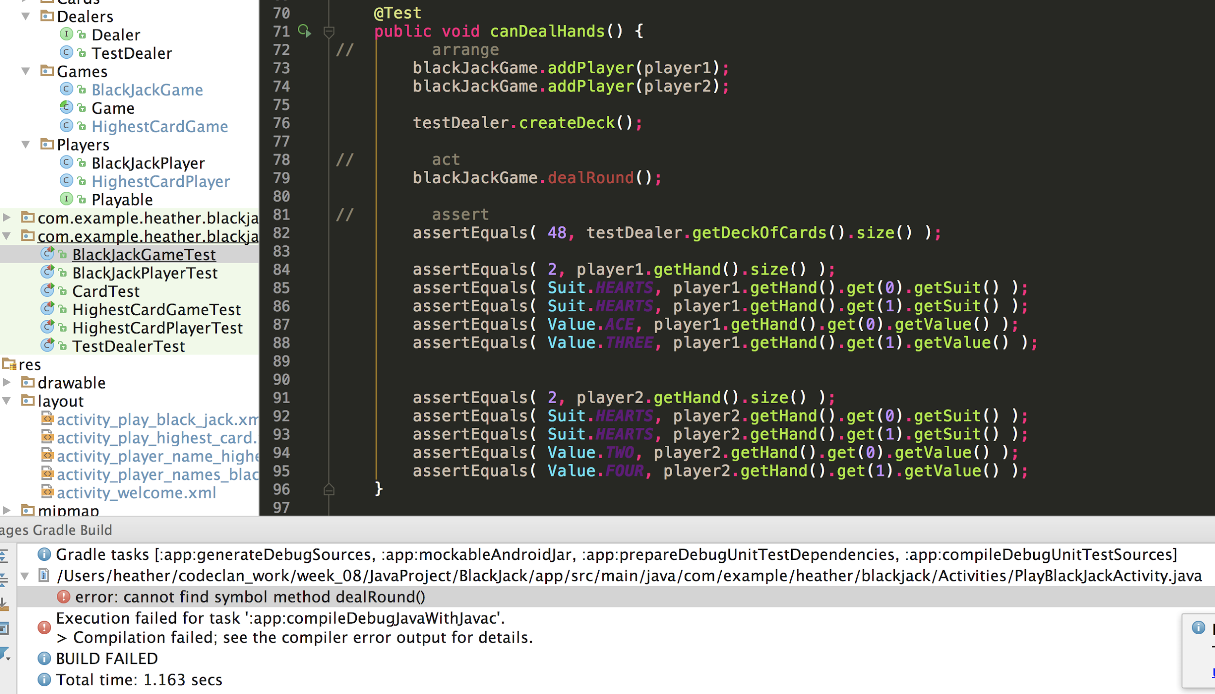

**Test passing**

